

Enabling multi-tenancy with Amazon EMR
Lab Instructions
V1

Introduction

A secure multi-tenant environment is always one of the top priorities for organizations building analytic applications on the cloud. Amazon EMR provides a comprehensive set of features to build highly secure multi-tenant Hadoop cluster resources and data. In this workshop, you will learn how to secure an Amazon EMR cluster using IAM Roles & policies, Kerberos, Encryption (at rest and in transit), and Apache Ranger to provide fine grained access control & auditing for common services running on Amazon EMR.
This workshop will walk you through hands on experience on the following concepts:

Part 1
- Using a FreeIPA server to host the domain and the users, groups for this lab
- Creating a Security Configuration to associate to an Amazon EMR cluster
- Launching a Kerberized Amazon EMR Cluster using the Security Configuration
- Enforcing storage-based authorization for datasets in Amazon S3 using EMRFS

Part 2
- Launch Apache Ranger Server as an edge node to implement fine grained authorization and auditing on applications running on Amazon EMR

Starting the lab

For this workshop, we will use CloudFormation to set up and create the resources required by the workshop labs.

Pre-requisites

IMPORTANT: Before you launch the CloudFormation stack, you need to create the default IAM roles for the EMR clusters.

Step 1) Create default IAM roles for EMR
To create the default EMR IAM roles in your account, run the following AWS CLI command:

aws emr create-default-roles --region us-west-2

For more information on creating the default IAM roles for EMR, please see the following link: https://docs.aws.amazon.com/cli/latest/reference/emr/create-default-roles.html

Step 2) Make that you have an existing EC2 Key Pair in the us-west-2 (Oregon) region. If you don’t already have a key pair in Oregon, please follow the EC2 Key Pair documentation to create a key pair in Oregon.

Once you have created the default IAM roles for EMR and you have an EC2 key pair in Oregon (see previous steps), you can launch the workshop CloudFormation stack. To launch the stack, click on the following link:

https://console.aws.amazon.com/cloudformation/home?region=us-west-2#/stacks/new?stackName=EMR-Multitenancy-Workshop&templateURL=https://emr-workshops-us-west-2.s3-us-west-2.amazonaws.com/multitenancy-workshop/cloudformation/CrossRealmMaster.template

The link above you take you to the CloudFormation console in us-west-2. Once there, click the “Next” button. On the “Specify Details” page, select your Key Pair under the “KeyName” field and click “Next” (leave all other settings as default) and follow the console instructions to launch/create the stack.

Note: It will take about 15-20 minutes for the stack creation to complete. Once the stack creation is complete, please proceed to the next the section to get started with the lab exercises.

Exploring the Architecture

A multi-tenant environment on Amazon EMR comprises of the EMR Cluster and a FreeIPA Server to host the domain, users and groups. In the workshop, we have integrated the FreeIPA server with the Amazon EMR using a bootstrap action. Individual users and users belonging to a group in the FreeIPA’s directory service are authenticated to the Amazon EMR cluster using Kerberos. These users, once authenticated, can ssh to the master node on Amazon EMR cluster as themselves. Amazon EMR uses System Security Daemon (SSSD) to map FreeIPA Server’s directory service groups to Hadoop groups.

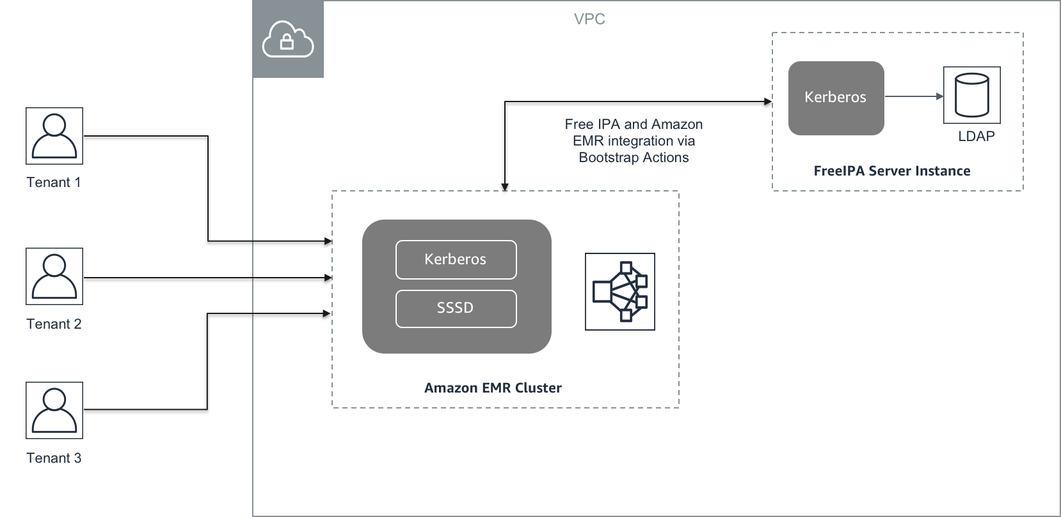

In this workshop, you will explore creating the users, logging into a Kerberized cluster and configuring JupyterHub to work with Kerbeos and AD/FreeIPA.

Activity 1: Working with Kerberized Amazon EMR Cluster

Introduction

Kerberos Authentication
Kerberos is a network authentication protocol created by the Massachusetts Institute of Technology (MIT). It uses secret-key cryptography to provide strong authentication so that passwords or other credentials aren't sent over the network in an unencrypted format.
In Kerberos, services and users that need to authenticate are known as principals. Principals exist within a Kerberos realm. Within the realm, a Kerberos server known as the Key Distribution Center (KDC) provides the means for principals to authenticate. The KDC does this by issuing tickets for authentication. The KDC maintains a database of the principals within its realm, their passwords, and other administrative information about each principal. A KDC can also accept authentication credentials from principals in other realms, which is known as a cross-realm trust. A common scenario for establishing a cross-realm trust relationship is to authenticate users from an Active Directory domain so that they can access an EMR cluster using their domain user account, using SSH to connect to the cluster, or working with big data applications and viewing Web interfaces.

What is provided

- The CloudFormation stack provisioned the following in the AWS account:

  - A VPC with 2 public subnets configured with appropriate DHCP Options
  - A Free IPA Server with the following created
    - Realm domain (EXAMPLE.COM)
    - Domain Users (emruserone, engineer, scientist)
    - Groups (data-engineers, data-scientists)
  - A Kerberized Amazon EMR cluster

Getting Started

Let’s get started!

CloudFormation should have launched a FreeIPA Server running on an EC2 instance and an EMR cluster which is configured with required Kerberos settings.

Implementing Kerberos authentication on Amazon EMR Cluster

- The CloudFormation stack will create a domain admin user named “emruserone”. Let’s verify if you can SSH to newly created EMR cluster using FreeIPA credentials (single sign-on). Run the following command to login to the Keberized EMR cluster as “emruserone”:

Note: The password for all users, including “emruserone” is: *S3cretPass21!
ssh -l emruserone <<emr-dns>>

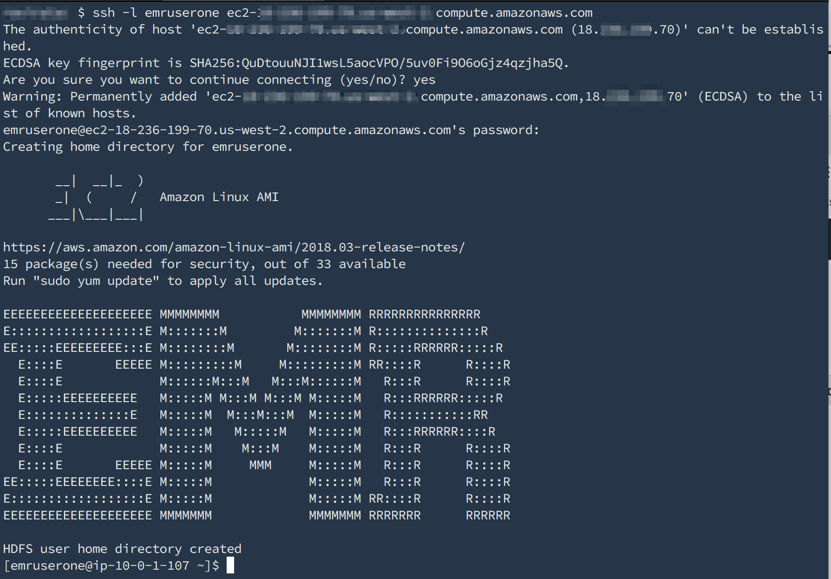
- Use the klist command to confirm whether the user is authenticated and has a valid Kerberos ticket. Use the kinit command to re-authenticate a user.
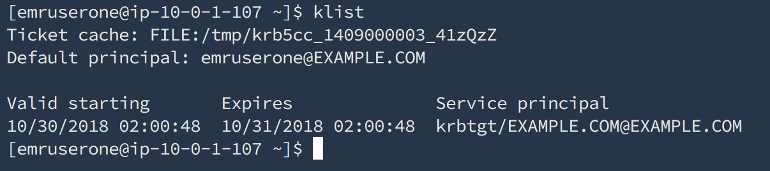
- Run Spark jobs after kinit to verify that the same Active Directory user can successfully run applications in a Kerberized cluster
spark-example SparkPi

After running the SparkPi application, go to the Amazon EMR console and choose your cluster. Then choose the Application history tab. There you can see information about the application, including the user that submitted the job:

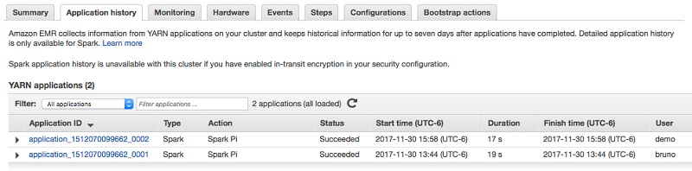

Try logging as different users (engineer, scientist) from the FreeIPA Directory Server as well users belonging to different groups.

Accessing JupyterHub running on Amazon EMR
Jupyter Notebook is an open-source web application that you can use to create and share documents that contain live code, equations, visualizations, and narrative text. JupyterHub allows you to host multiple instances of a single-user Jupyter notebook server. When you create a cluster with JupyterHub, Amazon EMR creates a Docker container on the cluster's master node. JupyterHub, all the components required for Jupyter, and Sparkmagic run within the container.
Sparkmagic is a library of kernels that allows Jupyter notebooks to interact with Apache Spark running on Amazon EMR through Apache Livy, which is a REST server for Spark. Spark and Apache Livy are installed automatically when you create a cluster with JupyterHub. The default Python 3 kernel for Jupyter is available along with the PySpark 3, PySpark, SparkR, and Spark kernels that are available with Sparkmagic. You can use these kernels to run ad-hoc Spark code and interactive SQL queries using Python, R, and Scala. You can install additional kernels within the Docker container manually.
In this workshop, JupyterHub running on the Amazon EMR is configured to work with Kerberos and OpenLDAP running on the FreeIPA Server.

  - From your browser, go to https://<EMR-Master-DNS-Name>:9443
  - If you receive a security warning, click on “Advanced” link and press the “proceed anyway” button.
  - Once you see the login screen, enter your credentials

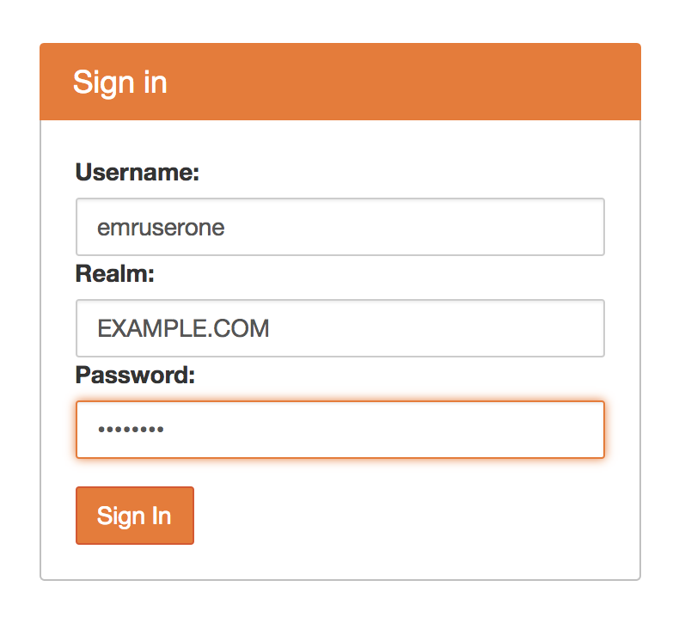

Activity 2: EMRFS Authorization for Datasets in S3

The EMR File System (EMRFS) is an implementation of HDFS that all Amazon EMR clusters use for reading and writing regular files from Amazon EMR directly to Amazon S3. EMRFS provides the convenience of storing persistent data in Amazon S3 for use with Hadoop while also providing features like consistent view and data encryption. When using Amazon EMR release version 5.10.0 or later, you can use EMRFS authorization for Amazon S3 to control access to EMRFS objects in Amazon S3 based on user, group, or the location of EMRFS data in Amazon S3.

Walkthrough: EMRFS Authorization
- From the Amazon EMR console, click on the Security Configuration link on the left-hand side of the screen
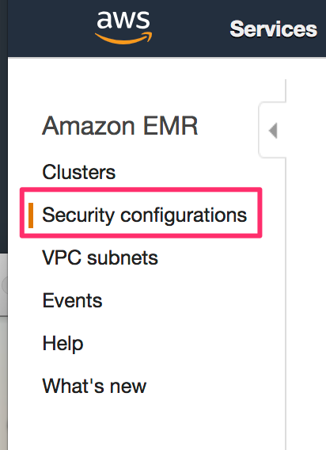
- Expand the Security Configuration title “Multi-tenancy-workshop-xxxxxxx-xxxx-xxxxx”. The Amazon EMR cluster used in this workshop was launched with this security configuration
- In this configuration, openLDAP users and groups have been mapped to IAM roles. These IAM roles have privileges that restrict them to certain S3 buckets or prefixes. The buckets have already been created as part of the cloudformation template.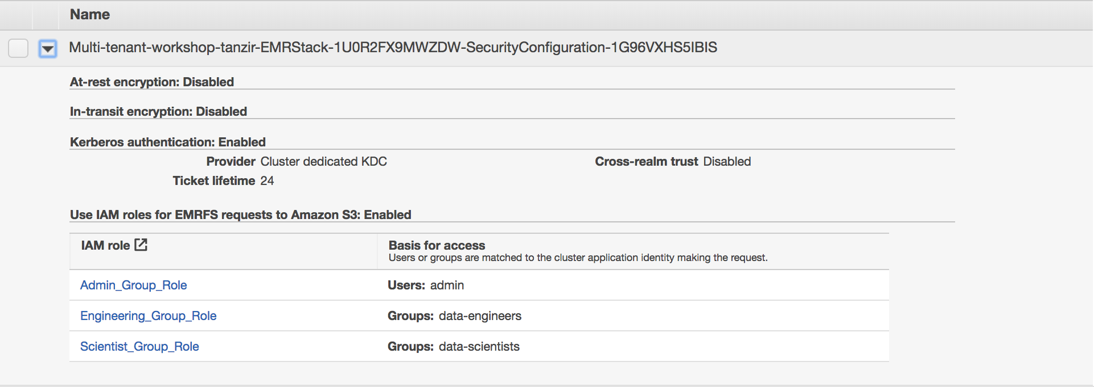
- As an example, User ‘engineer’ from ‘data-engineers’ group has only access to the bucket with the name ‘data-engineers-<AWS_Account_Id>. Similarly, user scientist from ‘data-scientists’ group will be able to access only bucket ‘data-scientists-<AWS_Account_id>
- Navigate to the Amazon S3 console to verify the buckets exists
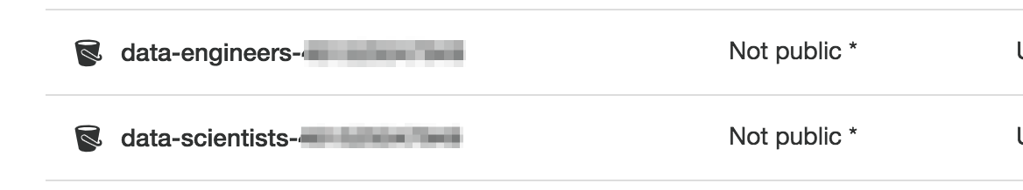
- Login using active directory users and run “id” command to validate their assigned group:
- Now you can run Hadoop commands and Hive queries on Hue to verify authorization to datasets per user.
- “engineer” should be able to only access bucket assigned for “data-engineers” group.
>> hadoop fs -ls s3://data-engineers-<<accound-id>>

  - But “engineer” should not be able to access bucket assigned for “data-scientists” group and you should see an access denied message

  - Same goes for “scientist” user. “admin” user on the other hand has access to all buckets and should be able to perform “ls” all buckets without any errors.
>> hadoop fs -ls s3://data-scientists-<<accound-id>>

- Repeat this security test by trying to create Hive tables where table location is assigned to their bucket. When login as “engineer” user in Hue for Hive, it will only allow to create Hive table when location is pointing to “s3://data-engineers-<<account-id>>” bucket, not the bucket for scientist.

Lab 3: Working with YARN Queues

This section shows how to leverage different YARN queues to submit jobs. Each of the YARN queues may have different resource capacity and associated with specific users and groups on the Amazon EMR cluster. YARN ResourceManager UI shows a list of available queues:

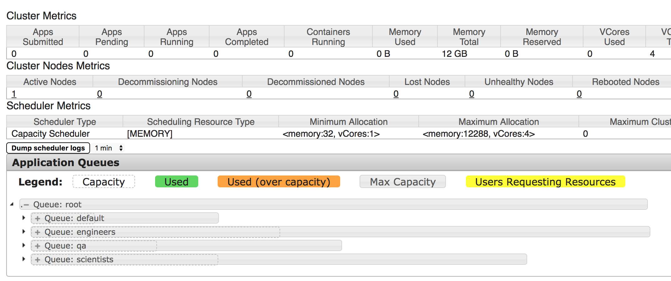

So, in this example, there are four queues:
  - Default
  - Engineers
  - QA
  - Scientists

Exercise #1: Now, use the user ‘engineer’ created in the previous section and log in to the EMR master node. Since he is from the ‘engineers’ group, he submits his job to ‘engineers” YARN queue:

- ssh -l engineer <<emr-dns>>
- [engineer@ 10-10-1-222 ~] spark-submit --queue engineers --class org.apache.spark.examples.SparkPi --master yarn /usr/lib/spark/examples/jars/spark-examples.jar

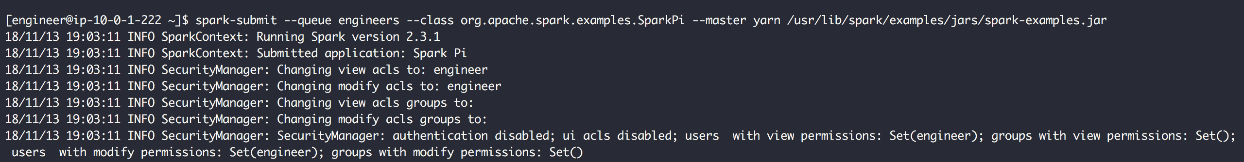

Here, the user ‘engineer’ is submitting a Spark job and passing a parameter “—queue” to reflect which queue it should use to run that Spark job:

YARN ResourceManager UI now reflects the same:

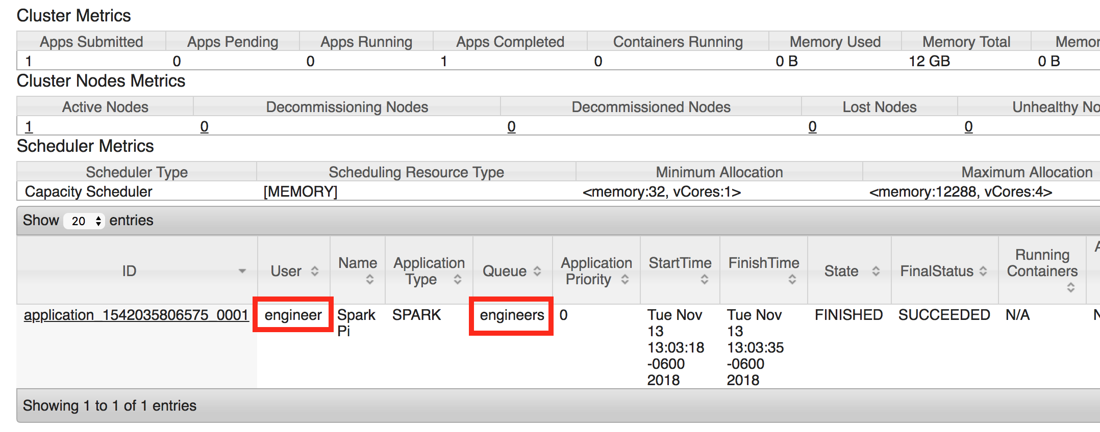

Exercise #2: Now, repeat the same exercise with a different user. For this exercise, use “scientist” from the “scientists” group.

- ssh -l scientist <<emr-dns>>
- [scientist@ 10-10-1-222 ~] spark-submit --queue scientists --class org.apache.spark.examples.SparkPi --master yarn /usr/lib/spark/examples/jars/spark-examples.jar

Notice that “scientists” value is passed for the parameter “—queue”. When the job is running, YARN ResourceManager UI also reflects that a job is running in a particular queue and a portion of the capacity is being used:

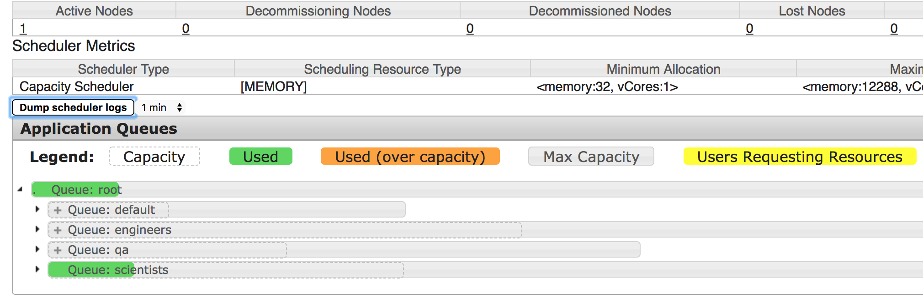

Now, go back to YARN ResourceManager UI to see the job status and queue association:

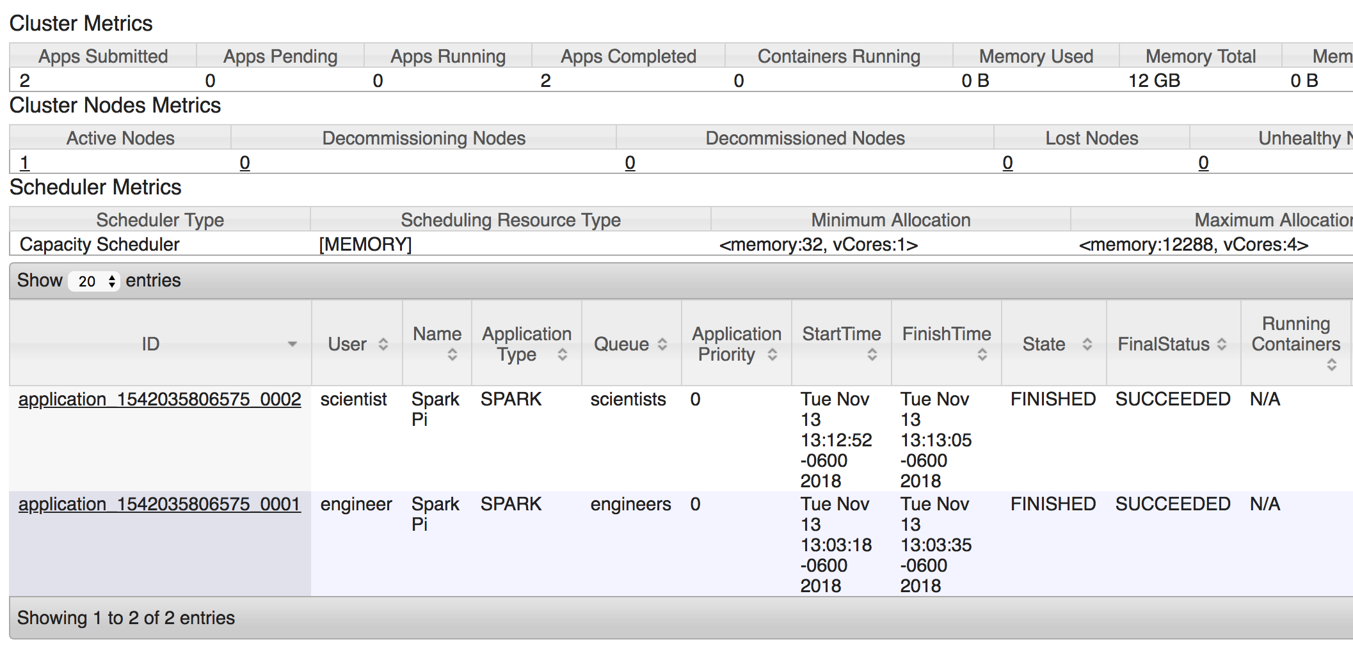

The above UI shows two different users submitted Spark jobs to their respective YARN queues. This is the way to isolate resource consumption between multiple users/groups in a multi-tenant EMR environment.

Lab 4: Authorization and Auditing using Apache Ranger on Amazon EMR

Introduction
Role-based access control (RBAC) is an important security requirement for multi-tenant Hadoop clusters. Enforcing this across always-on and transient clusters can be hard to set up and maintain.
Imagine an organization that has an RBAC matrix using Active Directory users and groups. They would like to manage it on a central security policy server and enforce it on all Hadoop clusters that are spun up on AWS. This policy server should also store access and audit information for compliance needs.
Apache Ranger™ is a framework to enable, monitor and manage comprehensive data security across the Hadoop platform. The vision with Ranger is to provide comprehensive security across the Apache Hadoop ecosystem. With the advent of Apache YARN, the Hadoop platform can now support a true data lake architecture. Enterprises can potentially run multiple workloads, in a multi-tenant environment. Data security within Hadoop needs to evolve to support multiple use cases for data access, while also providing a framework for central administration of security policies and monitoring of user access.

Amazon EMR with Apache Ranger (Granular Level Access Control): Exploring the architecture
Using the setup in the following diagram, multiple Amazon EMR clusters can synchronize policies with a standalone Apache Ranger security policy server. The idea is similar to a shared Hive metastore that can be used across Amazon EMR clusters.
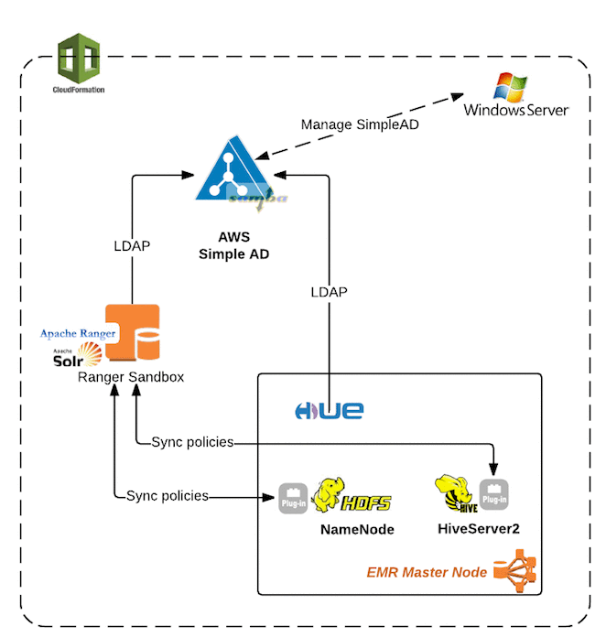

What’s provides

Note: Following resources required for this lab have been provided as part of the Cloudformation template
  - A VPC with at least two public subnets, or private subnets with NAT configured.
Note: If the Ranger server and EMR cluster are created in private subnet, you will need a bastion host or a VPN connection to access the Web UI links (Hue, Ranger).
  - An EC2 Key Pair
  - Configure IAM Roles for Amazon EMR permissions to AWS Services

Getting Started
Let’s get started with the Apache Ranger lab. Follow the instructions below to work with Apache Ranger and Amazon EMR
    - The Apache Ranger stack consists of the following:
- A Simple AD Server
- An Apache Ranger Server
- An Amazon EMR Cluster
In this lab, three users —analyst1, analyst2, and admin1—are set up for the initial authorization, as shown in the following diagram. Using the Ranger Admin UI, I show how to modify these access permissions. These changes are propagated to the EMR cluster and validated through Hue.

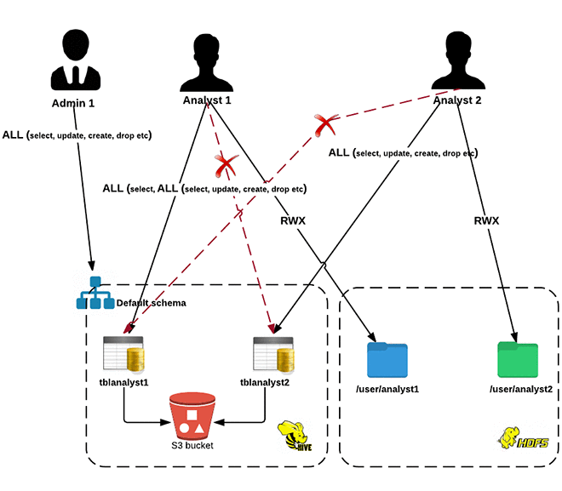
This section will focus on how to enable role-based access control for Hive/HDFS by using Apache Ranger.

- To access Ranger admin UI and Hue, use the below URLs
- Ranger admin UI: http://<ip address of the ranger server>:6080/login.jsp
- Hue web UI: http://<EMR master IP>:8888
- <TODO: Fill in the steps from the blog here> Now go through each step in Apache Ranger policies and try different RBAC scenarios as described in the blog post
- Note: When creating row level filter following the example given on the blog, use double quote instead of single quote: page=”yelp.com” to avoid parsing error.
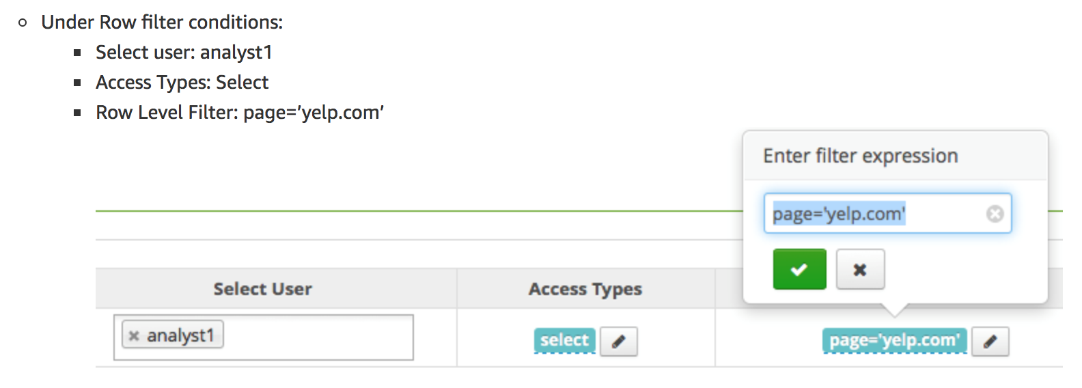
- Using Apache Ranger, you can also find who tried to access the Hive tables and see if they were “denied” or “allowed”
- Log back in to the Ranger UI as admin: http://<ip address of the ranger server>:6080/login.jsp
- Choose Audit and filter by “analyst1”.
- Analyst1 was denied SELECT access to the tblanalyst2 table.
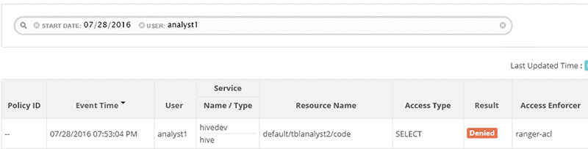

After the policy change, the access was granted and logged.
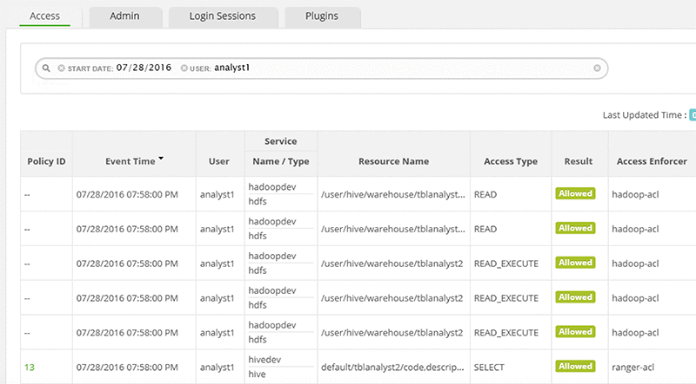
- The same audit information is also stored in SOLR for performing more complex and full test searches. The SOLR instance is installed on the same instance as the Ranger server.
  - Open Solr UI: http://<ip-address-of-ranger-server>:8983/solr/#/ranger_audits/query
  - Perform a document search
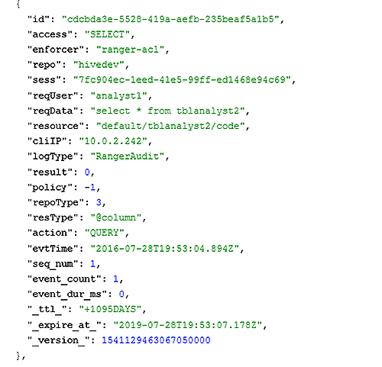
- Direct URL: http:// <ip-address-of-ranger-server>:8983/solr/ranger_audits/select?q=*%3A*&wt=json&indent=true

